Mobile Supply Chain Applications
For Intermec Terminal Emulator (ITE)

Merial

How to Perform Sub-Inventory Transfer through the Scanner

Author: Letitia Sims
Creation Date: May 10, 2011
Last Updated: May 10, 2011
Version: 1.0
Devices Used: Intermec CK3, VT/ANSI Application
Purpose: User Training

Approvals:

Roy Stephens

Kathy Jones

- Click Enter or “1” for Default
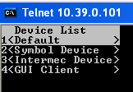

- Enter your Oracle user name and click Enter
- Enter your Oracle password and click Enter

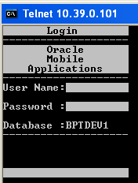

- The following Main Menu screen returns
- Click “2” for “Inventory Transfer”

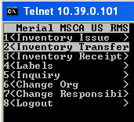

- Click “1” OR Enter for “Sub Transfer”
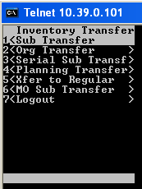

- Enter ATM in all caps (if not already chosen from using the scanner previously)
- To turn on all caps, press the following buttons:
- Press orange button
- Press “B”
- Press orange button
- Enter ATM

NOTE: If you make a mistake, hit the Enter button and start over

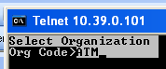

- Click Enter
- Enter the item number using the scanner keypad or scanning an item number barcode

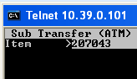

- The item description from Oracle is automatically populated
- With the scanner cursor on “From Sub” for sub-inventory, scan the location label

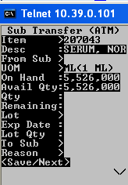

- The sub-inventory and locator will populate on the screen
- The UOM is automatically populated
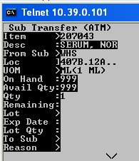

- The on-hand quantity for this sub-inventory and location is automatically provided
- The available quantity for this sub-inventory and location is automatically provided
- With the scanner cursor next to “Qty, enter the quantity to be transacted against
- Click Enter

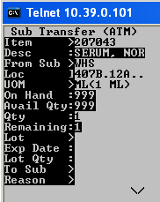

- The quantity next to “Remaining” will automatically populate the same quantity just entered
- Click Enter
- With the scanner cursor next to “Lot”, enter the lot number using the scanner keypad or scanning an lot number barcode
- Click Enter

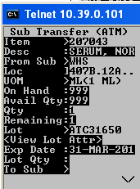

- The Lot “Exp Date” is automatically populated
- With the scanner cursor next to “Lot Qty”, enter the quantity to be transacted
- Click Enter
- A message returns indicating that the lot has been processed (i.e. validating this transaction is good for this item, locator and lot)

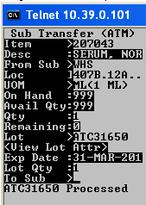

- With the scanner cursor on “To Sub” for sub-inventory, scan the location label
- The sub-inventory and locator will populate on the screen

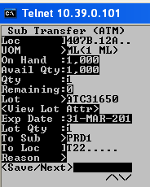

- The scanner cursor will stop next to “Reason”. This is an unused field; click Enter

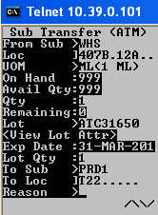

- Click Enter
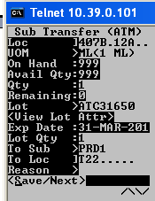

- Click Enter again to complete the transaction
- The message “Txn Success” will return to let the user know the transaction was completed.
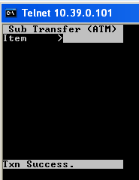

NOTE: The transaction is not complete unless the user clicks Enter where <Save/Next> is the choice.

- To exit this screen, click F2

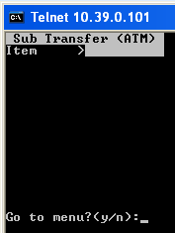

- The question “Go to menu? (y/n)” will return
- Click “Y” button
- The sub-menu returns

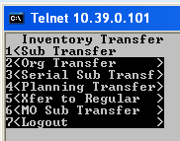

- click F2 again
- The main menu returns

